Instructions to Authors:
How to Use the Template
Xxxxx Y.,¹ and Mmmm N. *^{1,2}
¹ISSAT, University of Gabes, Gabes Tunisia
²Loratory of Xxxxxxx, University of Xxxxx,Town , Country
(E-mail: <insert corresponding e-mail address>)

These instructions provide guidelines for preparing abstracts for the International Conference on Materials for Environment, Energy and Bioresource. If you are using Microsoft Word ver. 6.0 or a later version, use this document as a template. Otherwise, simply follow the instructions given in this document as a reference[1,2]
Please submit the abstract within 2 pages.
Manuscript’s Styles
These instructions are typical for the implementation of the requirements.
- A4-size paper.
- Single-spaced text in two columns of 84.0 mm, with an 8 mm gutter.
Style Reference
The following Styles should be used for the abstract preparation.
- Title – The title should be the first item in the manuscript. It appears in 12-pt Times New Roman, bold type within a frame and is to be centered in the column.
- Author – The authors’ names should appear below the title. Do not use only initials with surnames (e.g., R. W. Atkinson) because it may make specific identification of an author difficult and cause confusion in the indexing and retrieval. Do not include professional/official titles or academic degrees. The presenter must be designated with an underline.
- Figures, Tables, and Equations –Remove all color from graphics.
- Graphical Abstract – The Graphical abstract provided the form in the next page should be submitted with the abstract.
References and Notes
[1] F. C. Küpper, M. C. Feiters, B. Olofsson, T. Kaiho, S. Yanagida, M. B. Zimmermann, L. J. Carpenter, G. W. Luther III, Z. Lu, M. Jonsson, L. Kloo Angew. Chem. Int. Ed. 2011, 50, 11598; b) In Special issue on Hypervalent Iodine Chemistry Recent Advances and Applications , Tetrahedron Symposium-in-Print Number 150 (Eds.: S. Quidéau, T. Wirth) Tetrahedron, 2010, 66, 5727.
[2] M. Ito, I. Itani, Y. Toyoda, K. Morimoto, T. Dohi, Y. Kita, Angew. Chem. Int. Ed. 2012, 51, 12555.

Graphical Abstract
To create your abstract, type over the instructions in the template box below.
Fonts or abstract dimensions should not be changed

Immobilization of Graphene Oxide on the Permeate Side of a Membrane Distillation Membrane to Enhance Flux
Worawit Intrchom, Sagar Roy, Madihah Saud Humoud and Somenath Mitra

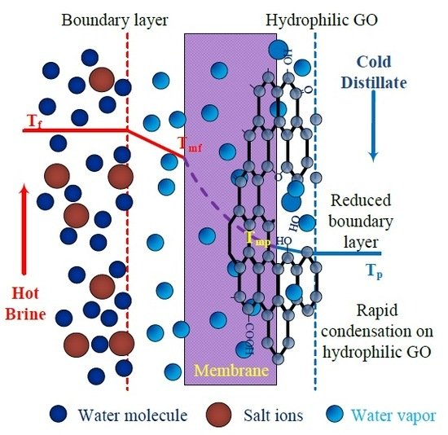
(Example)

